Bradford on Avon Flower Club Newsletter December 2015

The first thing is to thank all of the members and committee who helped to make the Christmas Open meeting such an enjoyable and successful evening. As well as a very entertaining demonstrator in Lee Berrill- the wine and nibbles, extensive Sales table, the slide showing giving information about our club all helped towards a very memorable evening. All the hard work paid off and we will be announcing the amount raised at our December meeting. This is very important to the club as it helps to finance the demonstrations we hold through the rest of the year.

Lee (as with all demonstrator’s) asked that photos of his designs were not put on social media but was happy for them to be used to promote clubs- so here are a couple to remind you of a very happy evening.

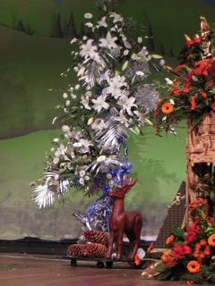

Festive Food and Flower Show in Blackpool
Two of our members took part in this big show. Cath Humphries entered one of the classes entitled “Indulgence” and Lucy Ellis was representing the South West Area in the Designer of the Year competition.

20 people entered this competition and Lucy got through to the last 10 on the second day and narrowly missed getting into the final 5. The competition was won by Alison Cooper of the Cheshire Area. Congratulations to Lucy for getting so far.

Emily Broomhead won the competition to represent Nafas at the WAFA Show in Barbados in June 2017.

Here are a couple of photos of Lucy’s designs.

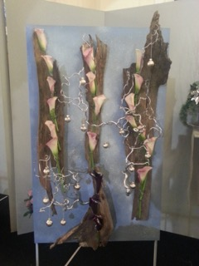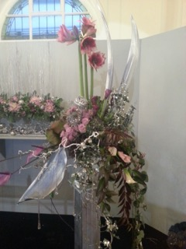

Practice Class Wednesday 25th November 2pm at URC Hall in Holt
The theme for this class is a (Floral) Christmas cake. For this you will need a posy pad- Rosemary can supply you with one for £1.50p but you need to let her know before next Tuesday as she is going to the wholesalers to buy them. For more information please phone Rosemary on 01225 858751

Thursday 3rd December Chelsea talk 7.30pm at Holt Village Hall
Cath Humphries and Lucy Ellis- members of the gold medal winning team for the South West Area of NAFAS will give a talk with photos all about their Chelsea experience and give you an insight about what goes on behind the scenes.
So for those of you lucky enough to have gone on the trip to Chelsea come along to relive the day and forget the dark winter outside! If you did not manage to get there come along to see how wonderful the South West area stand was.
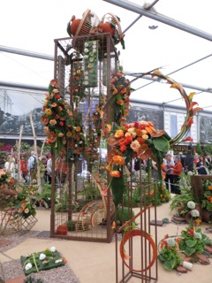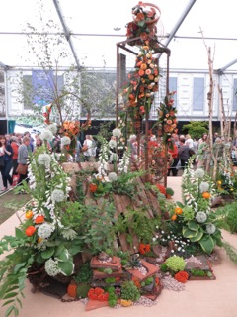

We are asking members to bring a plate of finger food for everyone to share afterwards.

Christmas Workshop in Masonic Hall in Bradford on Avon Saturday 5th December 10am-13.00
This is almost fully booked now but there a couple of places left. The price of the session is £25 and includes everything you need to make either a Christmas wreath or a Christmas table arrangement- tuition by Margaret Murray and Lucy Ellis plus tea/coffee and home made cakes.
For more information and to book a place please phone 01225 863640. When you book please indicate if you would like to make either the Christmas Wreath or the table arrangement. Bookings need to be made by Monday 30th November to allow time for purchasing all the things needed.

Members Dinner Thursday 7th January at Cumberwell Park.
Another reason it is worth joining the club is to be able to come along to our annual dinner as it is for members only. Having all enjoyed the meal so much last year we have booked to go to Cumberwell Park again.
Joan needs choices and payment at the meeting on 3rd December. If you cannot make this meeting please phone her on 01225 863878.

Club meeting Thursday 4th February 7.30pm at Holt Village Hall
We are planning a similar evening to the members meeting last February when members demonstrated pedestals with a different budget for each. Still in the planning stage!

Kew Trip Saturday 6th August.
Planning has to start a long way ahead! Cath will start collecting names and a £10 deposit at our February meeting- this will be for members and friends/family. We will then open the list to other clubs/ visitors in March.
The cost of the trip will be approximately £30/£35- to be confirmed. This includes the coach travel and the entrance fee.

Flower Arranger
The current editor of the Flower Arranger is standing down next year and for her last edition (Winter) she is asking each area to supply their top half dozen tips for the festive season. She needs about 20-30 words for each.
Here is an example of the sort of thing she is looking for
"Christmas puddings are often sold in red plastic holders. Keep these for the following year - they make ideal containers for a festive table arrangement"

If you have any ideas please let me have them and the committee will then chose the ones to send on.
Also on the subject of the Flower Arranger, Pam will shortly have to put in the order for next year’s Flower Arranger magazine. So if you have not put in your order so far she needs your cheque for £11.80p by 23rd Nov. Contact her on 01225 865700.

If you have not seen the current Winter Issue of this magazine I will bring one along to the December meeting as it features designs by quite a few of our club members from the Winter Flower Festival at the Bishop’s Palace in Wells last December. Among the 5 designers were our own Cath Humphries and Lucy Ellis and their designs were both featured. Also one by Margaret Murray and another by Lucy, Liz Harris and Jilly Heath.

This may be a bit early but I wish everyone a Happy and Peaceful Christmas and enjoy your festive flower arranging!

Helen
(on behalf of the committee)

